
Since 2024

Preface
A&S Enterprise is a new generation business house to explore and engage into the various business opportunities in Bangladesh. We are a team of professionals to venture into various fields starting from consultation services to constructions, exports-imports, supply of engineering, electrical and electronics to Army, Navy and Bangladesh Air Force including setting up of buying house. We are an enlisted supplier of Naval Store Sub Depot, Dhaka, Bangladesh. In addition, we are making our all-out efforts to contribute to the Solar Power Generation sectors of the Government of the Peoples Republic of Bangladesh.
Having talented minds and efficient technology we look forward to business diversification for creating job opportunities in the country. Our professionals are well connected to various government institutions including ministries and have track records to materialize governments projects in the most efficient manners.
Nevertheless, we leave no stone unturned to attain customer satisfaction both at home and abroad.

Vision

Attain trust as a well performed business house for quality services through competency, transparency, and innovation.

Mission

Foster commitment to deliver maintaining international standards of quality and safety within the scope of the projects.

Foreword
A&S Enterprise in a proprietorship business entity believes in partnership with all organizations/ institutions both national and international including government and private sectors. Being established in 2024 we are dedicated to doing business differently and innovatively. Our diverse businesses span from consultancy services to constructions, supply of all engineering, electrical and electronics to defence services including exports, imports and buying houses. We with our values and commitments would like to turn into a fastest growing company in Bangladesh.

A&S Enterprise believes that good ethics is the foundation for good business. Therefore, we believe in showing fairness and respect to our clients, partners, society and environment.

A&S shortly will turn into a private limited company.

Management

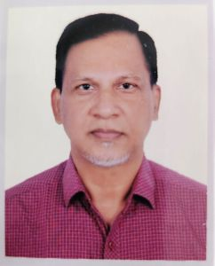  Proprietor | A&S is a proprietorship business entity headed by Commodore Sheikh Arif Mahmood, BN (Retired). Prior to the starting the business the Commodore has a noble carrier in Bangladesh Navy. As a born naval officer, he is a distinguished graduate of Bangladesh University of Professionals, National Defence College and Defence Services Command and Staff College. He besides his naval career was the Member (Harbour and Marine) of Chittagong Port Authority, Member of the Board of Chittagong Dry Dock Limited, Defence Advisor of Bangladesh to Malaysia and Non-Resident Defence Advisor of Brunei, Indonesia and Philippines. Prior getting into the business he served as the Managing Director of Dockyard and Engineering Works Limited, Narayangonj, Bangladesh an enterprise of Ministry of Defence managed by Bangladesh Navy.  He was also the Managing Director of Rupayan Dredging Limited, an organisation of Rupayan Group and Chief Operation Officer of Meghna Shipbuilders and Dockyard Limited.  He has vast experience of dredging related works as well.

Advisory Board
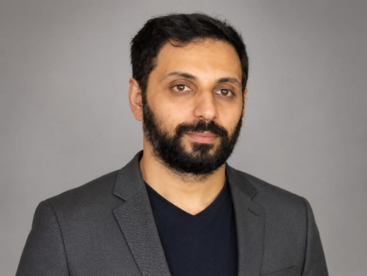Mr. Safiul Hamid Aasem  Advisor | Mr. Safiul Hamid Aasem is a well-experienced professional with expertise in finance, human resource management, business advisory, and corporate administration.  Previously, he served as Director of Finance and Human Resource Management (HRM) at Amplitude IT and Iqra Softwares Ltd. During his tenure, he was responsible for financial planning, budgeting, accounting, human resource management, and organizational development.  In addition, he has most valuable experience working in the cargo and logistics industry, where he gained practical knowledge in operations, administration, and customer service.  He has completed his Bachelor of Business Administration (BBA) from Bhuiyan Academy, affiliated with UK City College and Newport University, USA. His sound academic background, combined with his professional experience, has equipped him with strong leadership, financial management, strategic planning, and problem-solving skills.  In A&S Enterprise he is committed to contributing to organizational growth through effective financial management, sound business strategies, and efficient human resource practices.
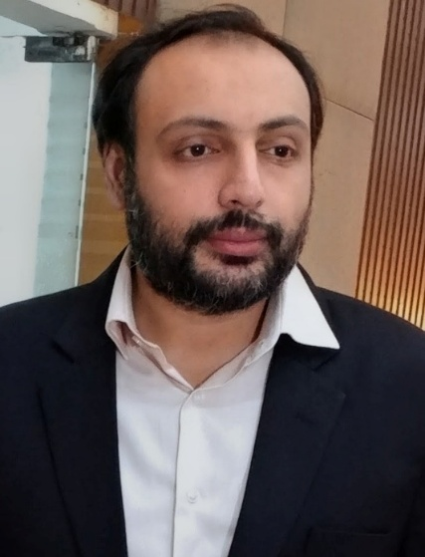  Mr. Taqiul Hamid Salem  Advisor | Mr. Taqiul Hamid Salem is a business professional with an academic background in Business Administration and extensive experience in business operations, marketing, management and international trade.  He completed his Bachelor of Business Administration (BBA) from Bhuiyan Academy, affiliated with City College UK and Newport University, USA, with majors in Marketing and Management.  Currently, Taqiul Hamid Salem serves as an Advisor at A&S Enterprise, where he provides strategic guidance and business development support.  Previously, he held the position of Director of Operations at Amplitude IT and Iqra Softwares Ltd, where he was responsible for overseeing operational activities, improving organizational efficiency, and supporting business growth.  In addition to his corporate experience, Taqiul is the Co-Owner of Ghhafoori Girişim Dış Ticaret Ltd. and Osmanlı Trader, with a focus on international trade, business development, and commercial partnerships.  His professional expertise includes:  Business Operations  Marketing Strategy  Management and Leadership  Business Development  International Trade  Strategic Planning  Operations Management  Taqiul is committed to building sustainable business relationships, driving operational excellence, and contributing to the growth of organizations through strategic leadership and effective management.
  Engineer Shihab Hossain,  BSc in EEE. MSc in ETE.  Technical Advisor | Shihab is a seasoned professional in Operations and Project Management with more than 22 years of experience in renewable energy, telecommunications, ICT and higher education. He has successfully led solar power, IT, and digital infrastructure projects in Bangladesh. His career includes key roles with Ericsson (Airtel & Robi Projects), BTCL (Transmission, Switching & the country's first Submarine Cable deployment) under NORTEL NETWORKS NETAS consortium, Northern University Bangladesh (NUB), Health-Tech organizations, Satellite Communications, IIG, and ISP businesses. He also served as an Adjunct Faculty, integrating industry expertise with academic excellence.  His core competencies include technical operations, EPC coordination, project management, network infrastructure, and digital transformation. He is experienced in due diligence for business transformation and mergers, stakeholder management, procurement, budgeting, and regulatory compliance. Holding advanced qualifications in Engineering with specialization in Financial and Communication Management, he combines strong technical knowledge with strategic business insight. He has a proven track record of leading multidisciplinary teams and delivering complex projects on time and within budget.  Recognized for his strategic leadership, analytical thinking, and innovation and consistently drives for operational excellence and sustainable business growth. He is committed to advancing Bangladesh's renewable energy and digital transformation initiatives while delivering measurable business value with integrity and professionalism.
Independent Technical Advisor | Engr. Mazharul Islam Faisal  BSc. in EEE, MSc in EEE, MS in Development Economics, PhD (Business, ON)  Executive Engineer, Power Grid Company of Bangladesh (ON).
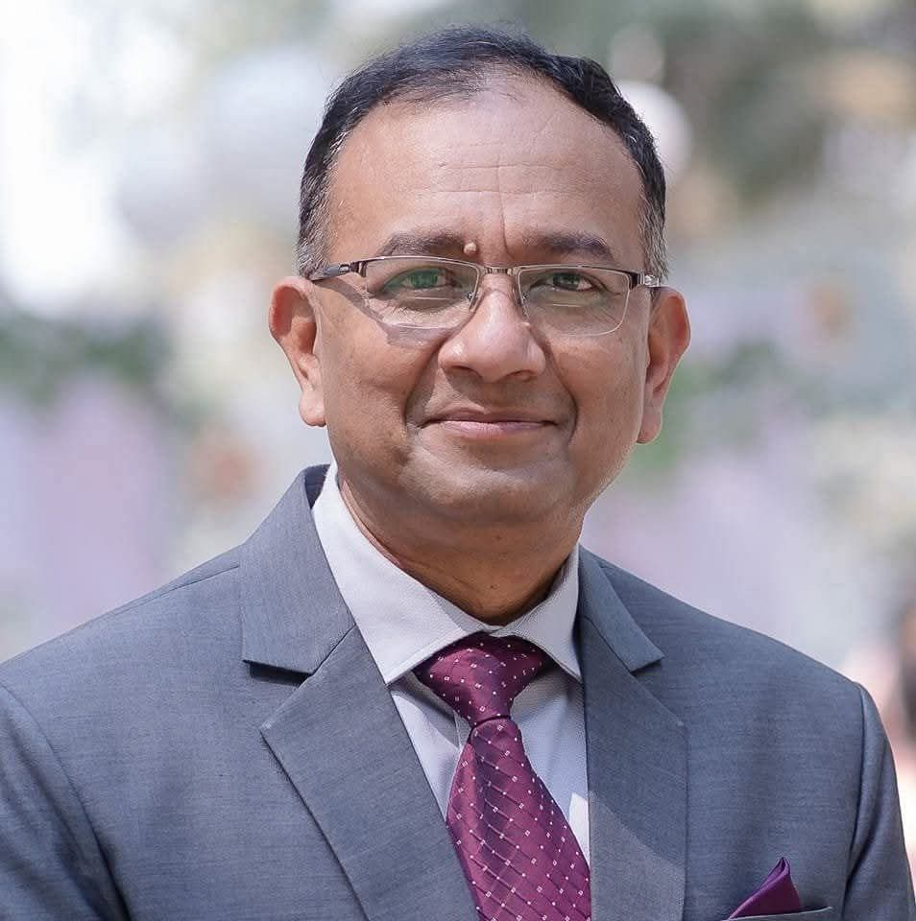  Captain Akhter Hassan, BN (Retd)  Advisor Logistics | Captain A S M Akhter Hassan, psc, BN (Retd.) - Former Director of Pay, Pension & Accounts, Bangladesh Navy & Former Chief Executive Officer, Capita Group  He is a highly accomplished former officer of the Bangladesh Navy with over 33 years of distinguished service in strategic administration, logistics and supply chain management, financial management, procurement, transport management, inventory control, and organizational governance.  Throughout his naval career, he held several senior leadership appointments, including Director of Pay, Pension & Accounts, Director of Naval Education Services, and Director of Naval Supply & Transport . In these capacities, he was entrusted with significant responsibilities encompassing policy formulation, financial oversight, logistics planning, procurement management, and institutional development.  Following his retirement from military service, he served as Chief Executive Officer of Capita Group, where he provided executive leadership in corporate strategy, business planning, governance, stakeholder engagement, and project oversight. His professional expertise spans public administration, corporate management, regulatory compliance, contract administration, human resource leadership, and operational excellence.  Captain Hassan holds a Master of Military Studies from the Naval Command College of the People’s Liberation Army, China, where he graduated First in Class (A+), as well as an MBA (GPA 3.74) from Southeast University, Bangladesh.  Recognized for his integrity, strategic foresight, and results-oriented leadership, Captain Hassan brings a rare combination of extensive military experience and senior executive management capability, positioning him strongly for senior leadership, advisory, strategic management, and board-level roles across both public and private sector organizations.  Captain A S M Akhter Hassan, psc, BN (Retd.) can provide -  Strategic Leadership • Financial Governance • Logistics Excellence • Corporate Management

Directors
  Engineer Muhammad Asadul Azam  Chief Executive Director | Engineer Muhammad Asadul Azam is a seasoned Electrical and Electronic Engineer with over 25 years of professional experience in power systems, infrastructure, telecommunications, industrial engineering, project management, and business development. He is a graduate of Bangladesh University of Engineering and Technology (BUET) with a B.Sc. in Electrical & Electronic Engineering and an Executive MBA, he has successfully led large-scale engineering projects across the telecom, healthcare, industrial, and energy sectors.  Throughout his career, he has held senior leadership positions at organizations including J&C Impex Ltd., Edison Electronics Ltd., ICDDRB, EDOTCO Bangladesh, Robi Axiata, BOC Bangladesh, and New Zealand Milk Bangladesh. His expertise covers electrical power systems, substations, generators, HVAC and VRF systems, renewable energy, project execution, procurement, operations and maintenance, and strategic business planning.  Engineer Asad has a proven track record of delivering complex engineering solutions, optimizing operational efficiency, and leading multidisciplinary teams. He has successfully managed projects involving power infrastructure, gas turbines, hospital engineering systems, telecommunications network power solutions, and commercial HVAC installations while achieving significant cost savings and operational improvements.
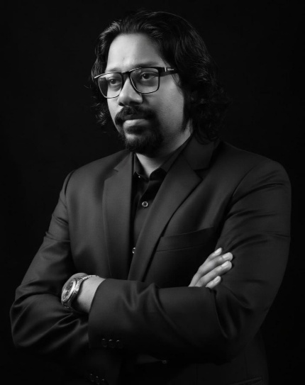  Engr. A.K.M Mahmud Hossain  Executive Director (ICT) | Engr. A.K.M. Mahmud Hossain is a seasoned business leader and technology executive with over 23 years of distinguished experience in Information & Communication Technology (ICT), telecommunications, digital infrastructure, and strategic business management. He has built an outstanding reputation for driving organizational growth, leading complex technology initiatives, and delivering large-scale infrastructure projects for government, enterprise, and private sector organizations.  As an accomplished executive, he has successfully led business transformation initiatives, developed strategic partnerships with global technology vendors, and managed multidisciplinary teams in the execution of mission-critical ICT and telecommunications projects. His expertise spans corporate strategy, business development, digital connectivity, broadband infrastructure, enterprise networking, project governance, commercial negotiations, and operational excellence.  Before joining RD Global Limited, he served in senior leadership roles at Summit Communications Limited (SCL), where he played a significant role in the development and expansion of Bangladesh’s nationwide telecommunications infrastructure. Throughout his career, he has consistently demonstrated strong leadership, strategic vision, and a commitment to innovation and sustainable business growth.  He holds a Bachelor of Science (B.Sc.) in Electrical & Electronic Engineering (EEE) and is an ITIL® Expert, reflecting his strong technical foundation and commitment to international best practices in technology and service management.  Widely respected for his integrity, strategic thinking, and results-oriented leadership, Engr. Mahmud Hossain continues to contribute to Bangladesh’s digital transformation by delivering innovative, scalable, and sustainable ICT solutions while fostering long-term value for customers, partners, and stakeholders.
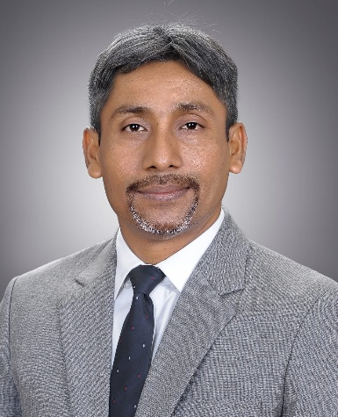  Executive Director (Solar & New Business) | Engr. M. Mahmudul Hasan is an Electrical and Electronic Engineer with over 20 years of professional experience in the power, energy, telecommunications, engineering, construction, and development sectors in Bangladesh. He has held key technical and leadership positions with leading organizations, including Banglalink Digital Communications Ltd., Ericsson Bangladesh, Nokia Networks Bangladesh, Oras Invest, and DETEC (BD) Ltd.  He is the Proprietor of Fix & Weld Engineering and ZET International, Chairman of BARAL FESD, Secretary & Director (Education) of Humanity First Bangladesh, and Director of Yehi Ltd. Under his leadership, numerous projects have been successfully implemented for government ministries, Power Grid Bangladesh PLC (PGCB), private sector organizations, and international development initiatives.  His expertise includes power transmission and distribution, electrical engineering, telecom network planning, infrastructure development, project management, procurement, renewable energy, and humanitarian project implementation. He has also participated in professional training, technical meetings, and seminars in the United Kingdom, Germany, Italy, France, Belgium, the Netherlands, Singapore, Sri Lanka, Nepal, and India.  Engr. Hasan is committed to advancing Bangladesh's energy security, promoting sustainable infrastructure, and developing skilled human resources to support the country's industrial and economic growth. He holds a Bachelor of Science in Electrical and Electronic Engineering and is a Life Member of the Institution of Engineers, Bangladesh (IEB).
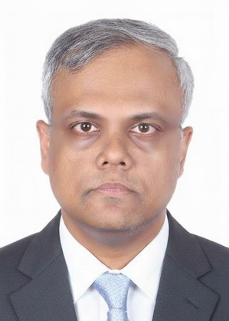  Engineer Taief Tanvir  Technical Director (Planning & Strategy) | Engineer Taief Tanvir is a veteran professional with over 20 years of international leadership experience spanning Bangladesh, Vietnam, Malaysia, and Myanmar. He has expertise in driving enterprise-wide technical vision, infrastructure planning, and strategic investment governance, with a strong focus on optimizing large-scale utility and network operations.  Holding a B.Sc. in Electrical & Electronic Engineering from BUET and an IPMA Project Management Certification, Mr. Tanvir brings a powerful blend of engineering expertise and strategic oversight. He has led multi-million-dollar CAPEX and OPEX portfolios, ensuring disciplined allocation aligned with long-term business and infrastructure objectives.  Throughout his career, Mr. Tanvir has consistently translated complex technical challenges into high-impact strategic outcomes. He has overseen nationwide transport planning and infrastructure operations covering thousands of active elements. Notably, he led critical post-merger integration audits, including the Airtel Bangladesh–Robi Axiata network consolidation.  By integrating robust procurement practices, lifecycle cost optimization, and financial performance modeling, he has delivered measurable improvements in CAPEX and OPEX.  Mr. Tanvir is recognized for his ability to align technical execution with strategic business goals, strengthen governance frameworks, and drive sustainable, high-efficiency infrastructure development at scale.
Technical Operation Head | TBA
Business Development Head | Mr. Bulbul Ahmed
Facilities Head (NZK Group & Rupganj site office) | Mr. Saydur

A&S Enterprise - Legal Status
1. A&S Enterprise is a registered company in Dhaka North City Corporation, Dhaka, Bangladesh, license number: TRAD/DNCC?026489/2024.
2. A&S Enterprise is a registered company in Dhaka Chamber of Commerce and Industries, registered number: ECNASE202501001502
3. Tax Identification Number (TIN): 628304768903.
4. VAT Identification Number (BIN): 006877595-0203
5. Export Registration Certificate number: 260326210858625.
6. Import Registration Certificate number: 260326112237425.
7. Buying House Registration, serial number: (DOT/BH/IMP)- L-2291.

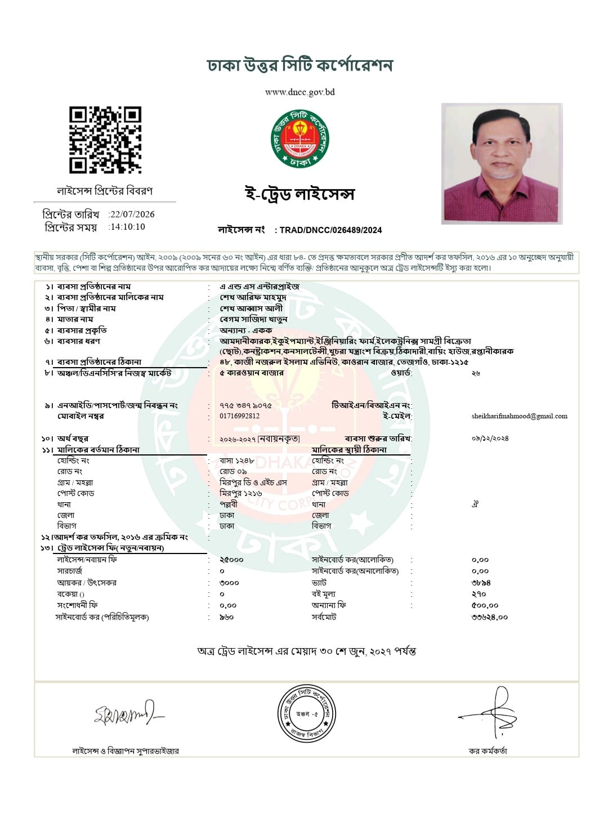

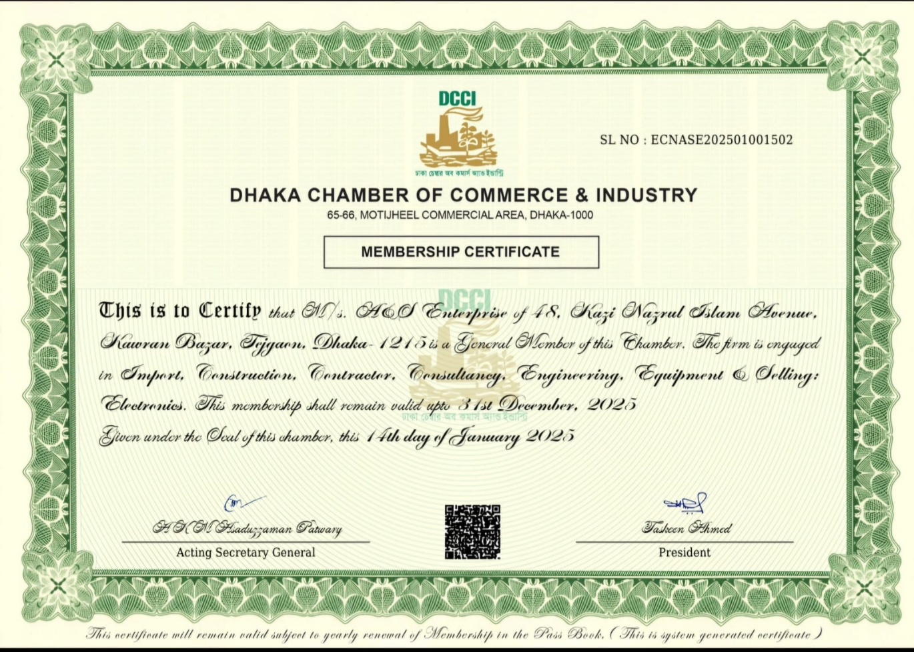

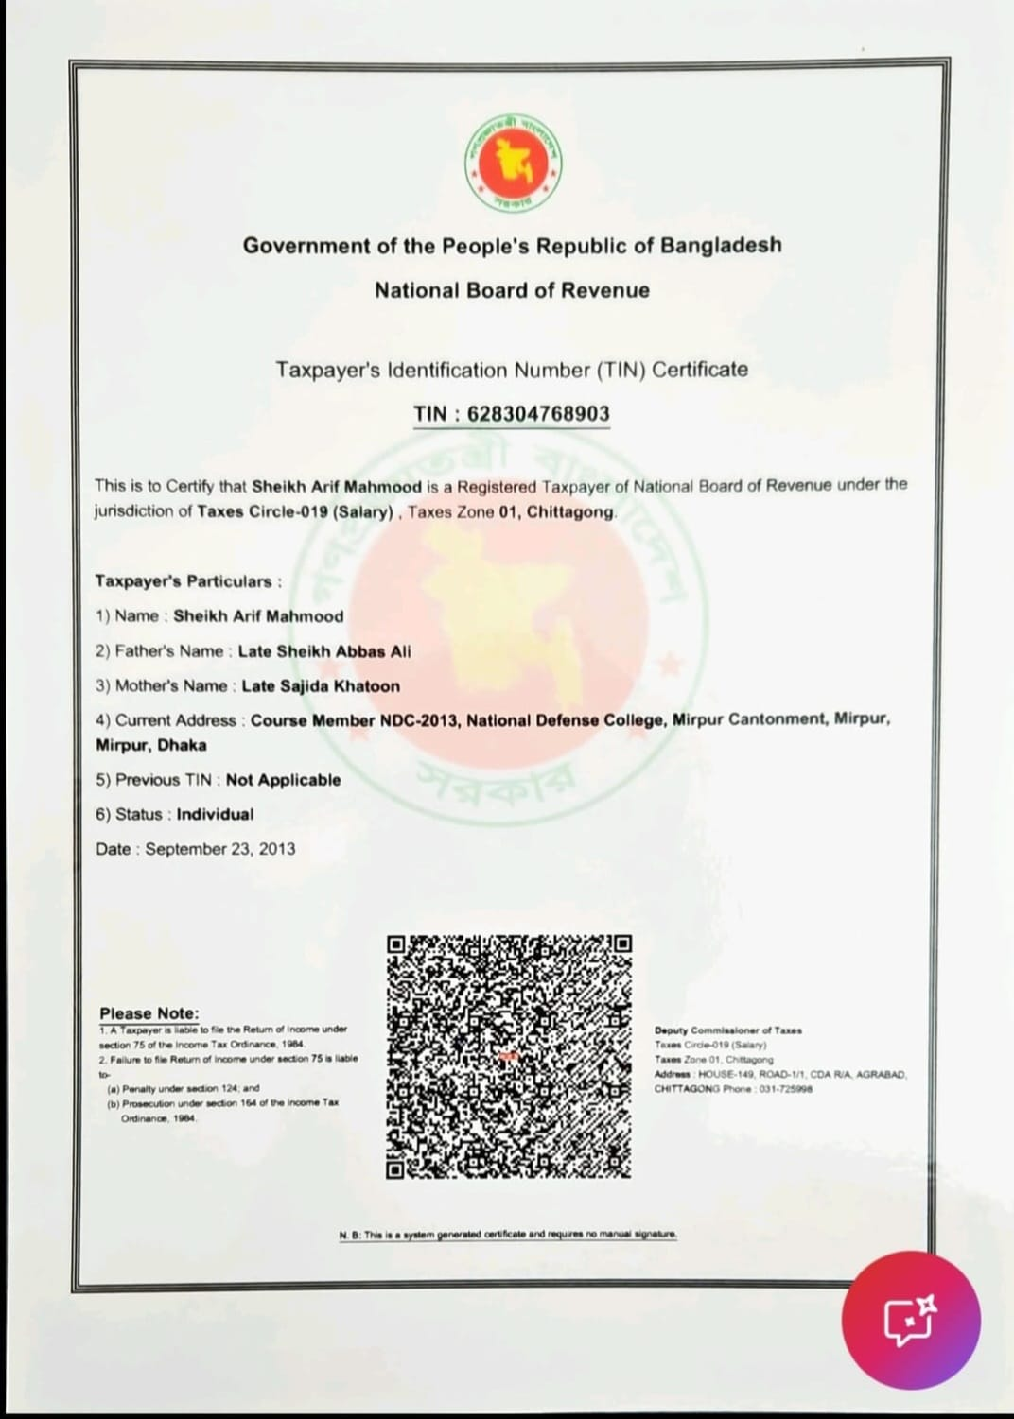

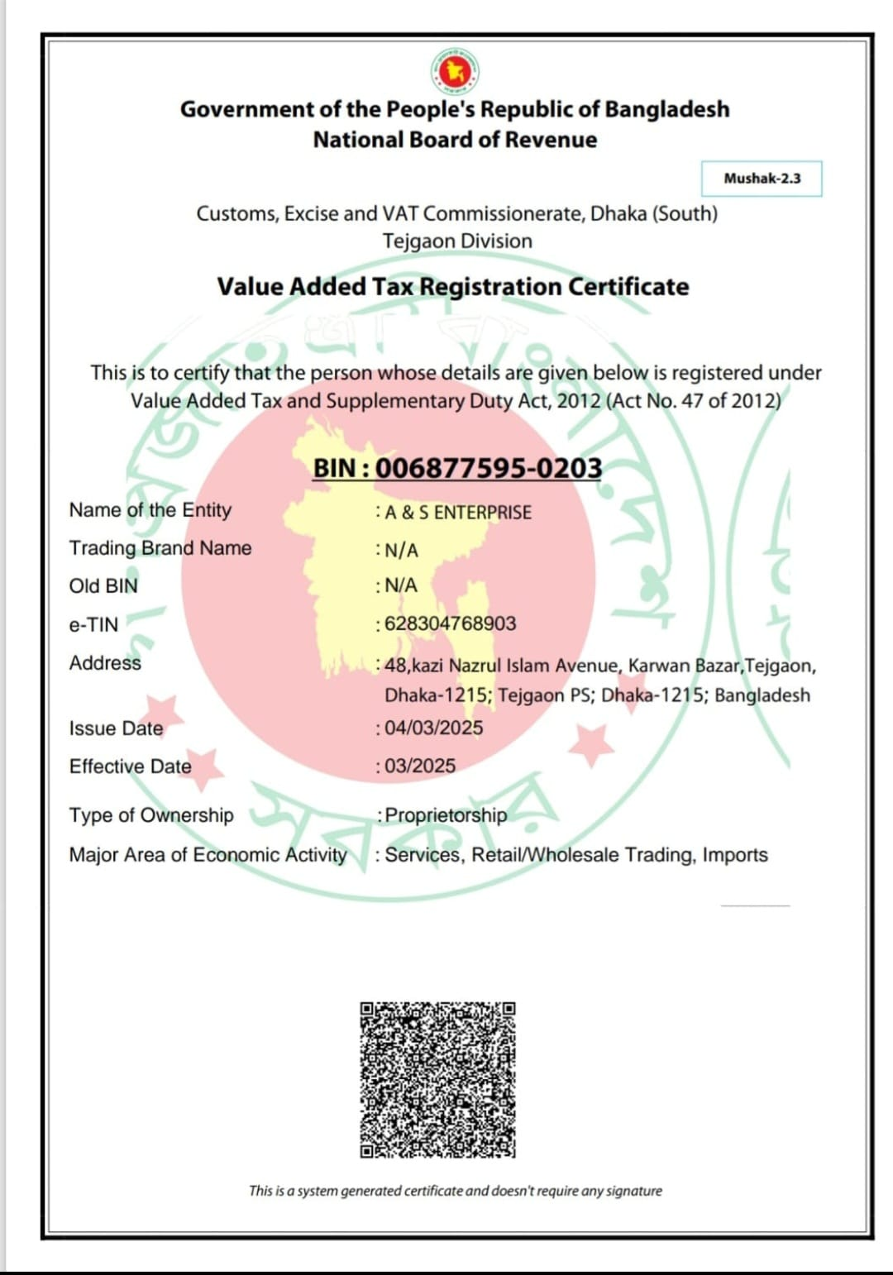

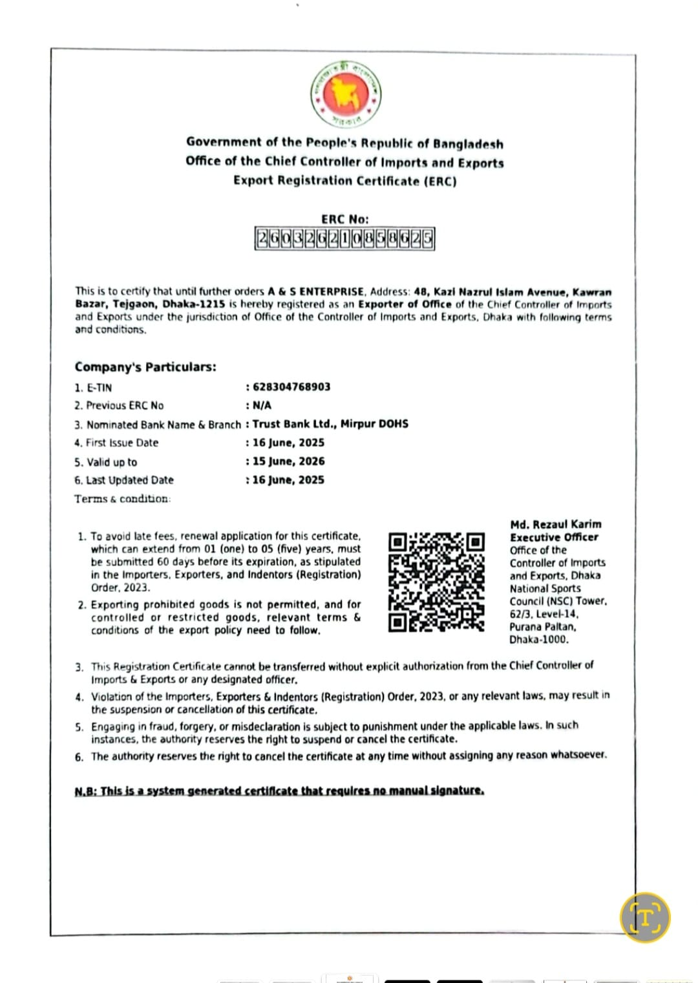

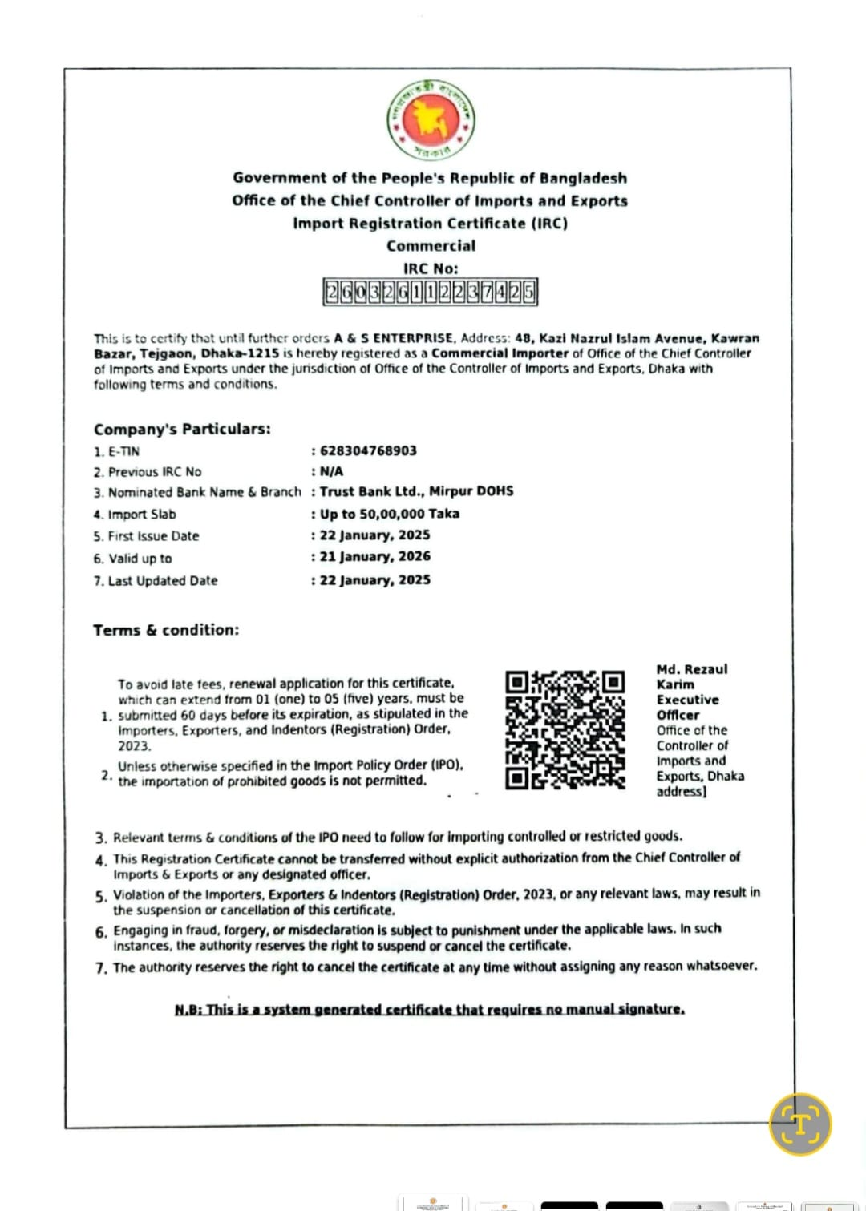
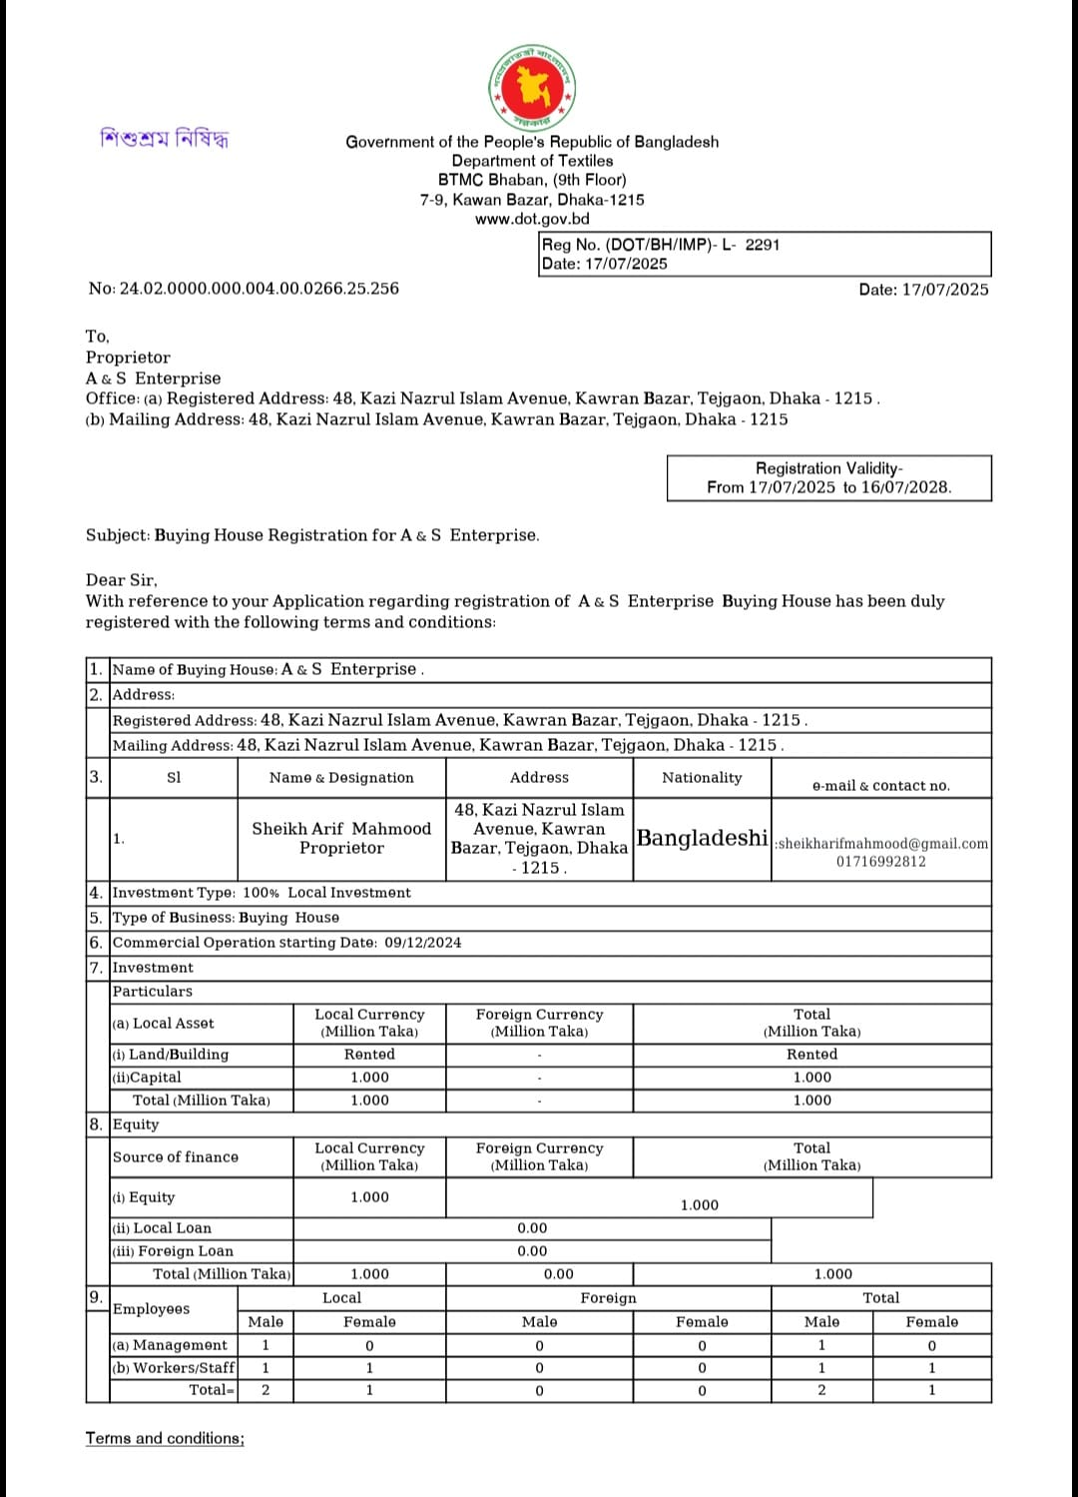

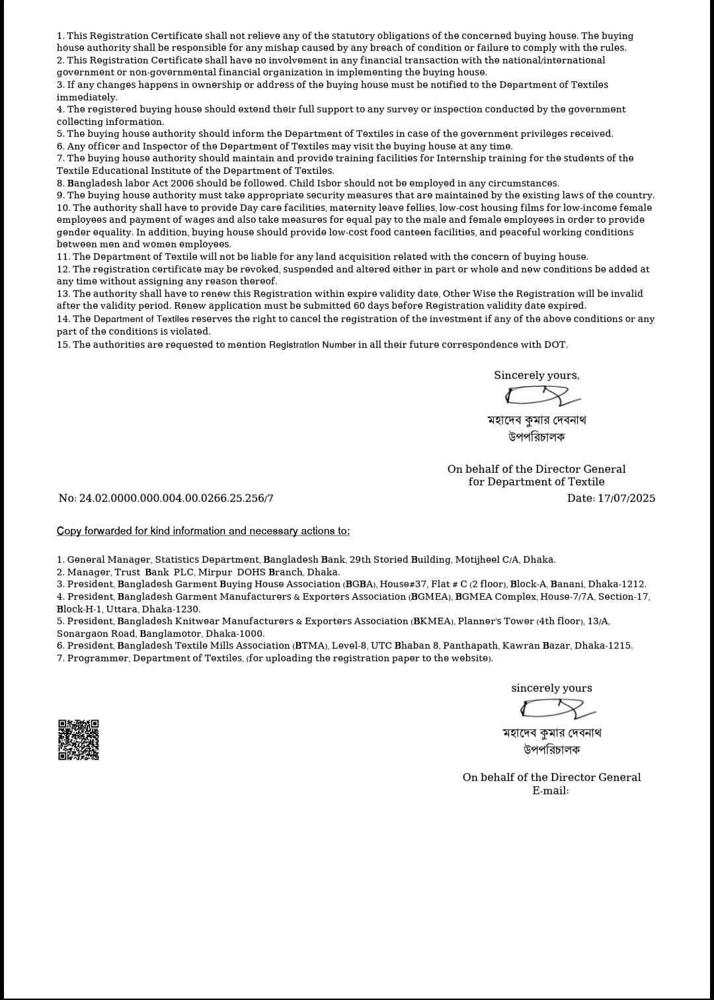

Corporate Office –

48, Kazi Nazrul Islam Avenue
Karwan Bazar
Tejgaon, Dhaka – 1215
Mobile:+8801716992812
Email: asenterprise171211@gmail.com
mail@asenterprisebd.com
Web: asenterprisebd.com

